Manual for PVACreator Twitter

Click this character “+” to create a task, then just name it:
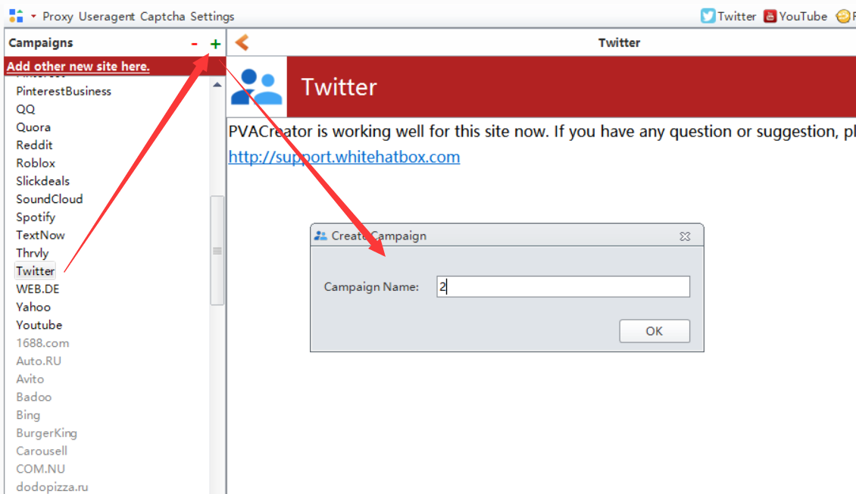

Following are the necessary variables needed to enter data before run：
- Email Information
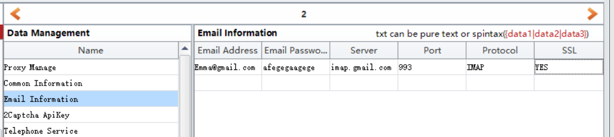
If you are using other domains to register account, and if you do not know where to find the server information, you can Google it, or follow this manual to check if you can find the related information. I will send it this file to you attached with this manual.

2, 2captcha ApiKey
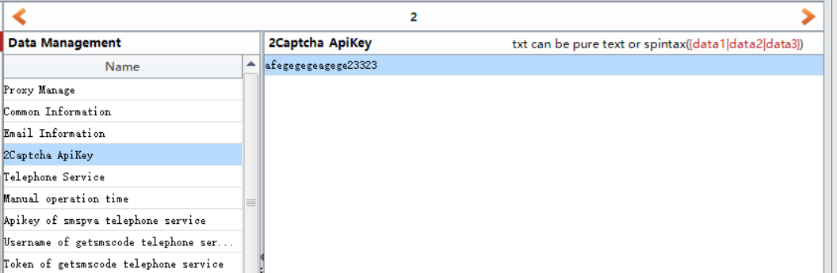
Visit 2captcha website, then register an account, then charge for your account, then enter your account apikey in this filed. If Twitter asks for captcha during register, then software will auto use this service to auto solve it.
https://2captcha.com/

3, Telephone Service
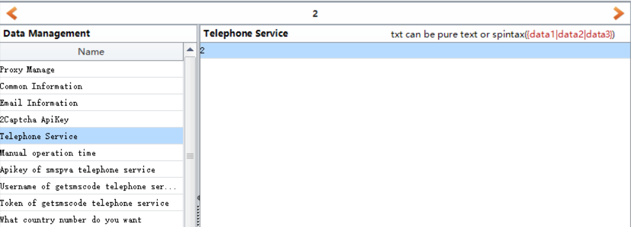
This is the 3rd party phone service we are using in this software, it is used to auto take and verify phone number if Instagram asks for during login in.
If you enter 1, then please register an account in smspva, then charge for your account, then you can find your account apikey in your account profile panel. Then enter it to “Apikey of smspva telephone service” field.
http://smspva.com/
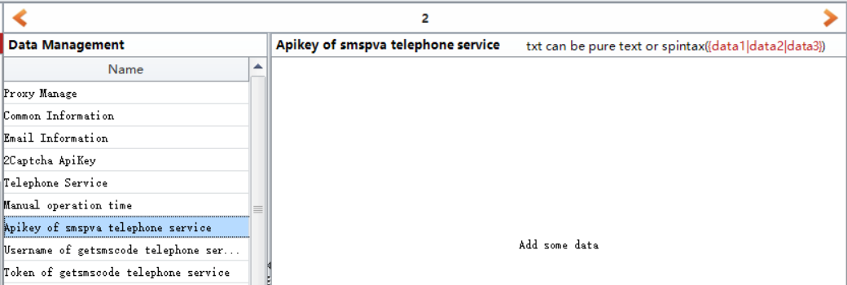
If you enter 2, then please register an account in getsmscode, then charge for your account, then you can find your account username and token in your account profile panel. Then enter them to “Username of getsmscode telephone service”and ”Token of getsmscode telephone service” fields.
http://getsmscode.com/
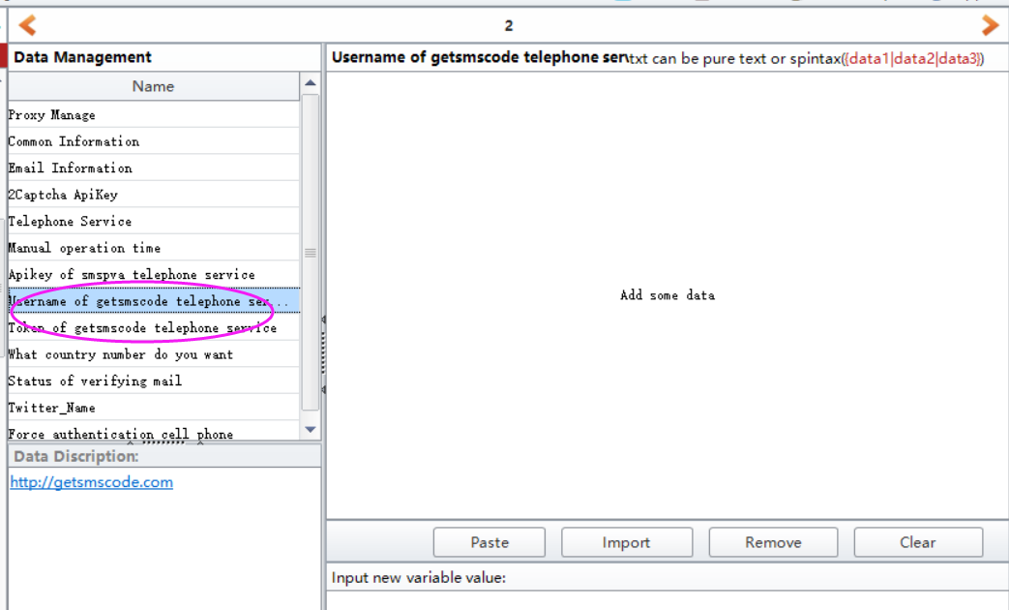
If you enter 0, which means you need to use yourself phone number to register. Then please enter a pause time in “Manual operation time” filed, and confirm you have enough time to enter the phone number and code manually during register. The unit of this option is million seconds.
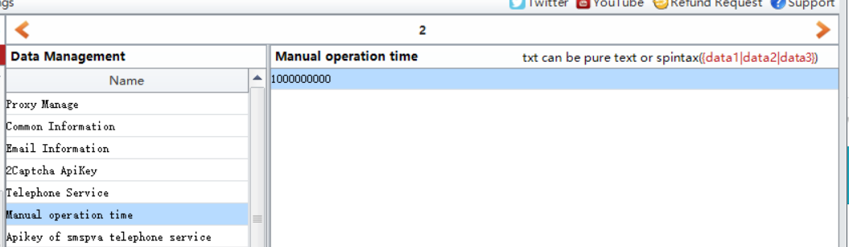

4, What country number do you want
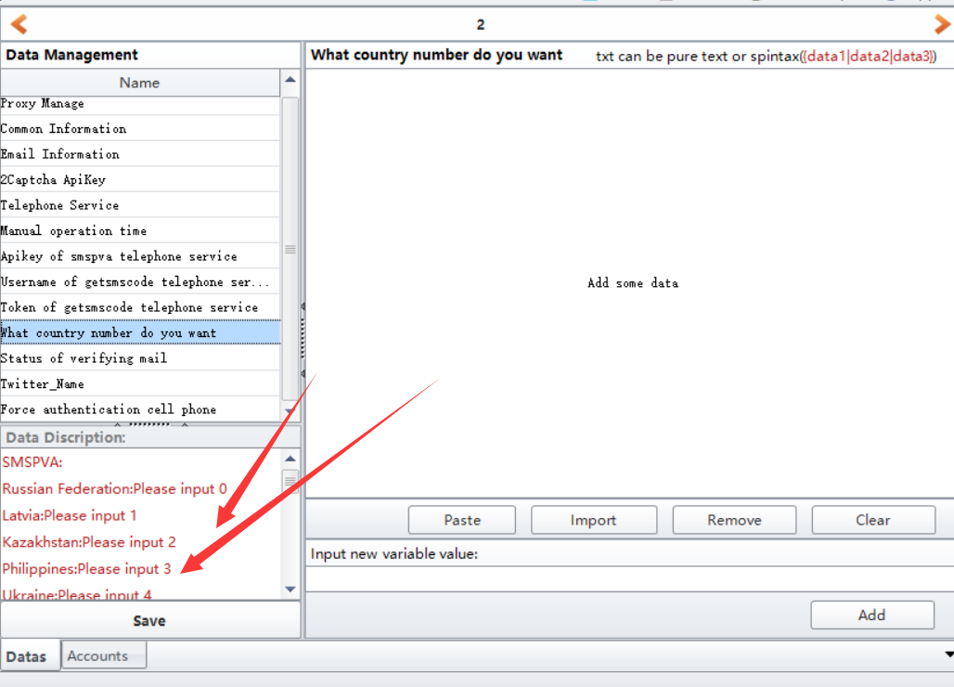
Choose which country phone number you want to use to verify your account.

5, Proxy Manage
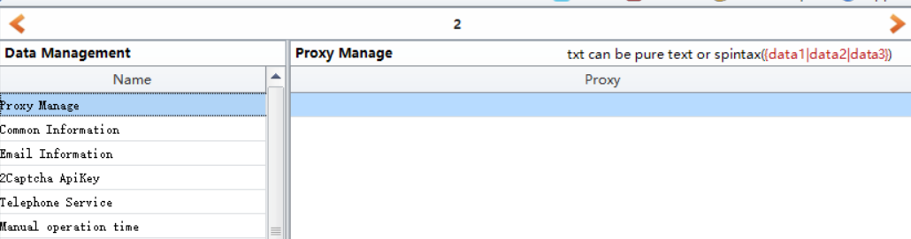
If you do have proxies and wish to create many accounts, then please enter your proxies in this filed.

6, Save
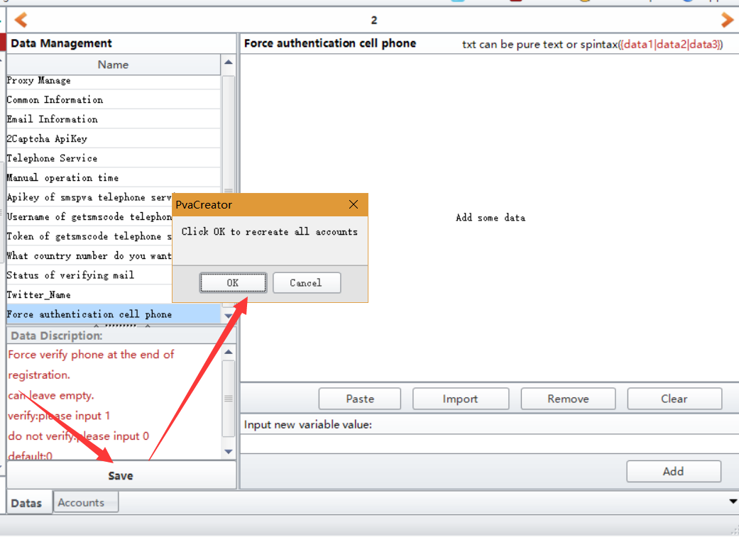

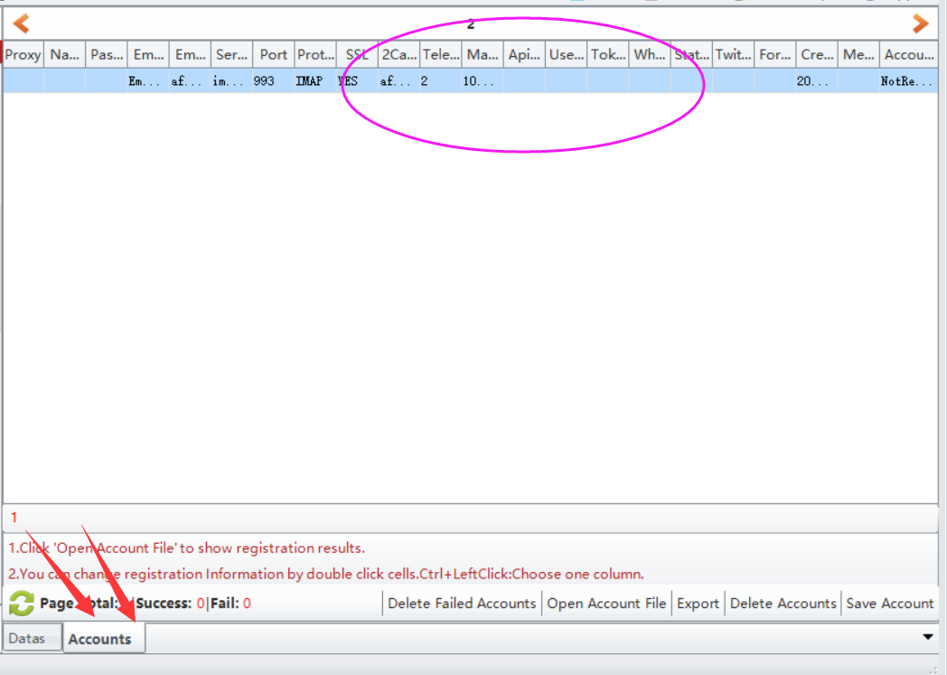

7, click Start button to start to run.
When it starts to run, here will be a debug window open, and you can view the whole running process.
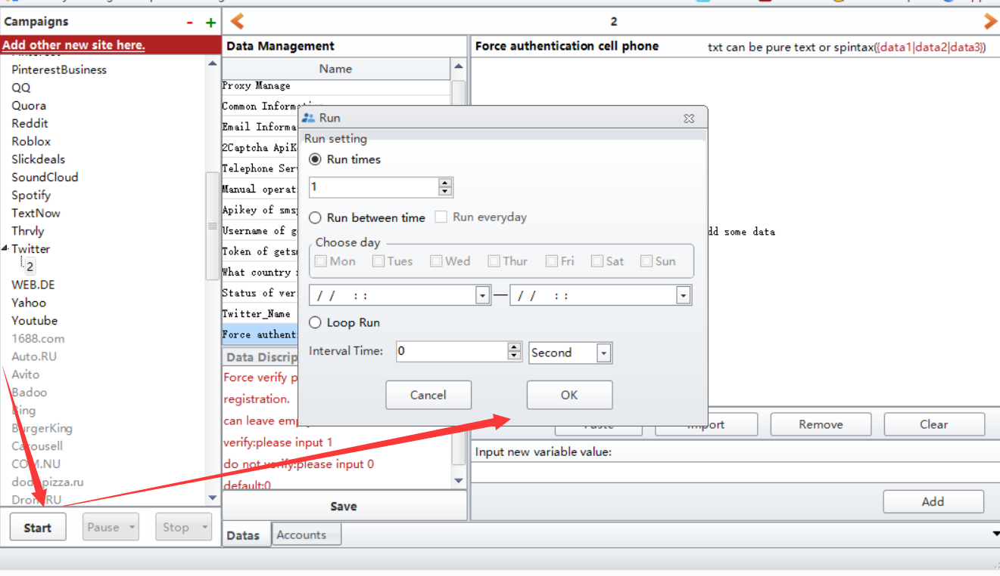

Options under “Bind Data”:
Import from file: import the data from your local prepared file at a time. Note: please choose the column first where you need to upload the data to.
UseRandom: custom some letters, numbers to auto generate data for these information. Such as full name, age, password. Note: please choose the column first where you need to custom and auto generate data.
Eg: if the first character is Funny, i will auto generate 1-4 number behind it. The first picture is the settings, the second one is the result it generates.
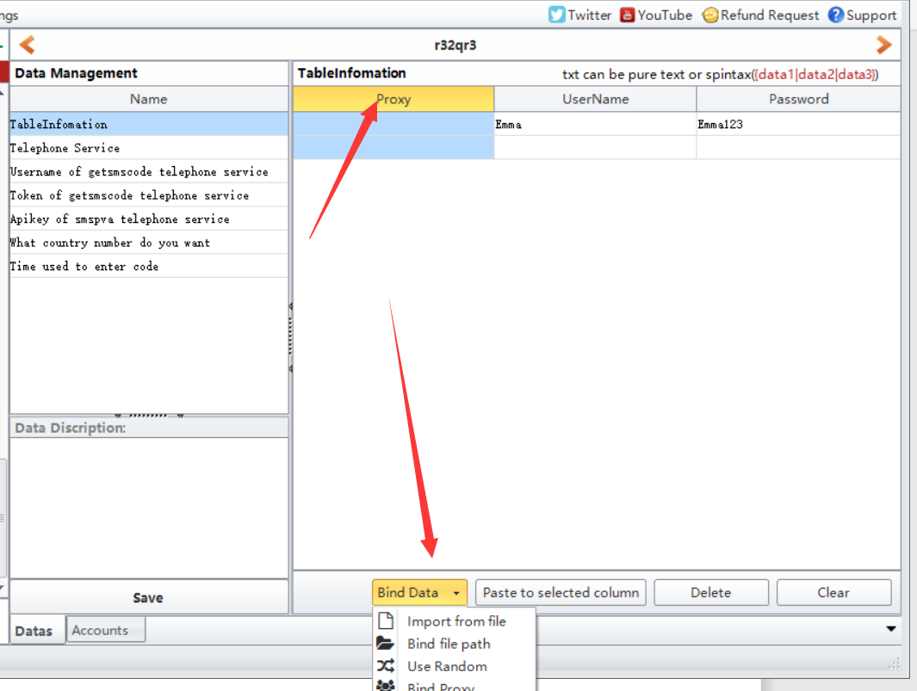
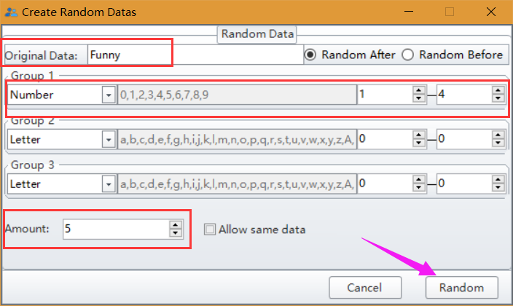
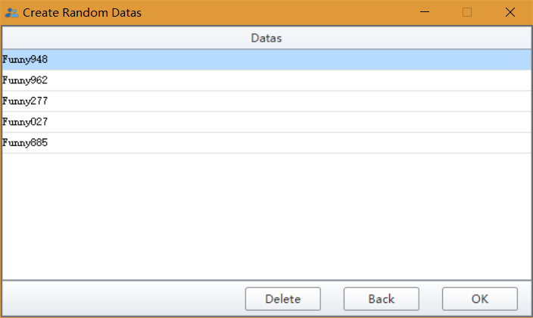
Bind Proxy/Useragent: bind proxy/useragents to these data at a time.

