How to Register Outlook Accounts

1. Click the “+” button to create a task name
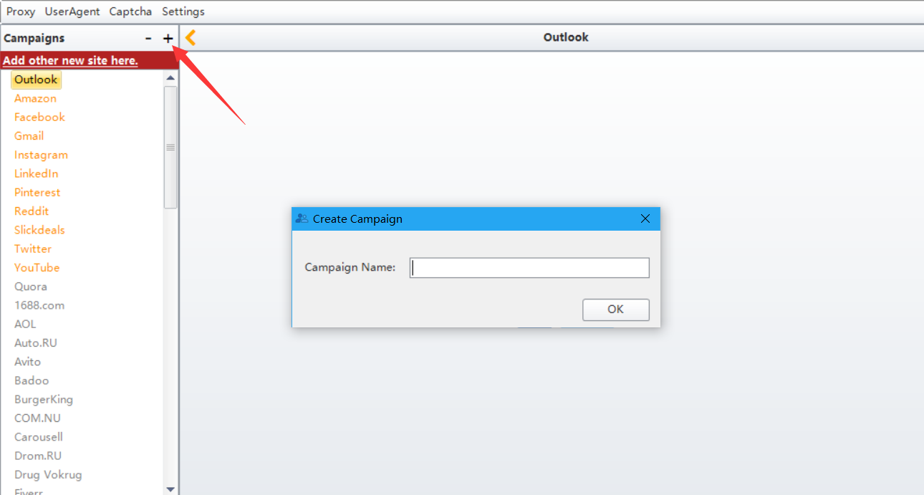

2. Add the First name, Last name manually or import multiple data from your prepared local file
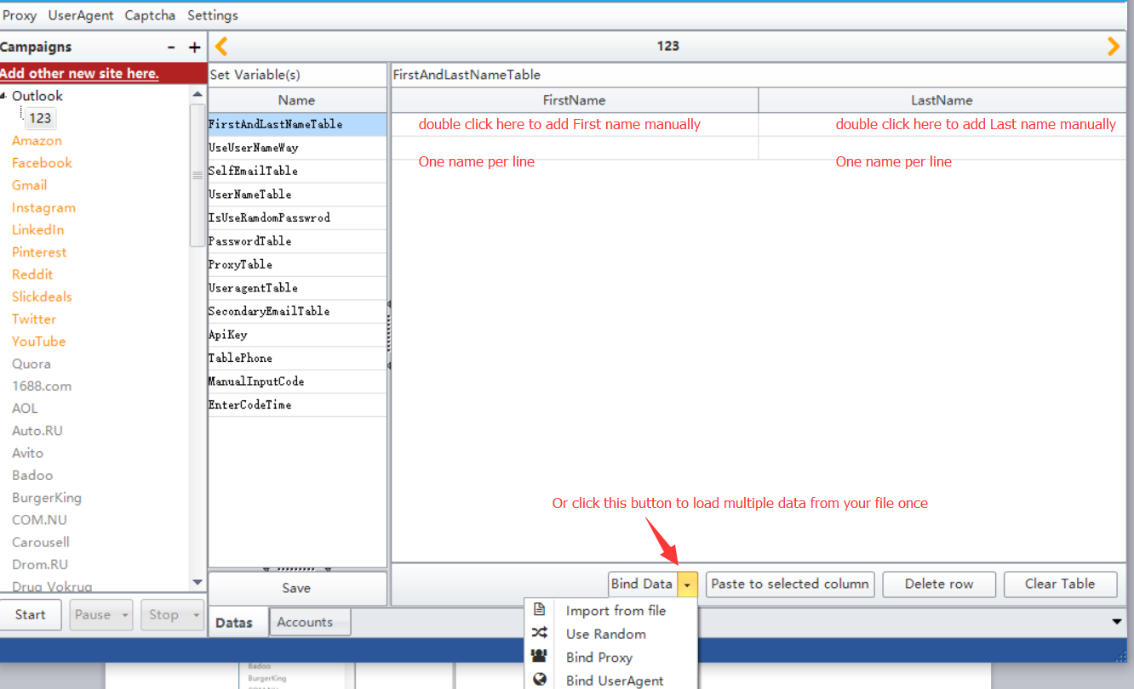

3. Fill in number 1-3. 1 represents using your own email domain. 2 represents using outlook.com 3 represents using hotmail.com
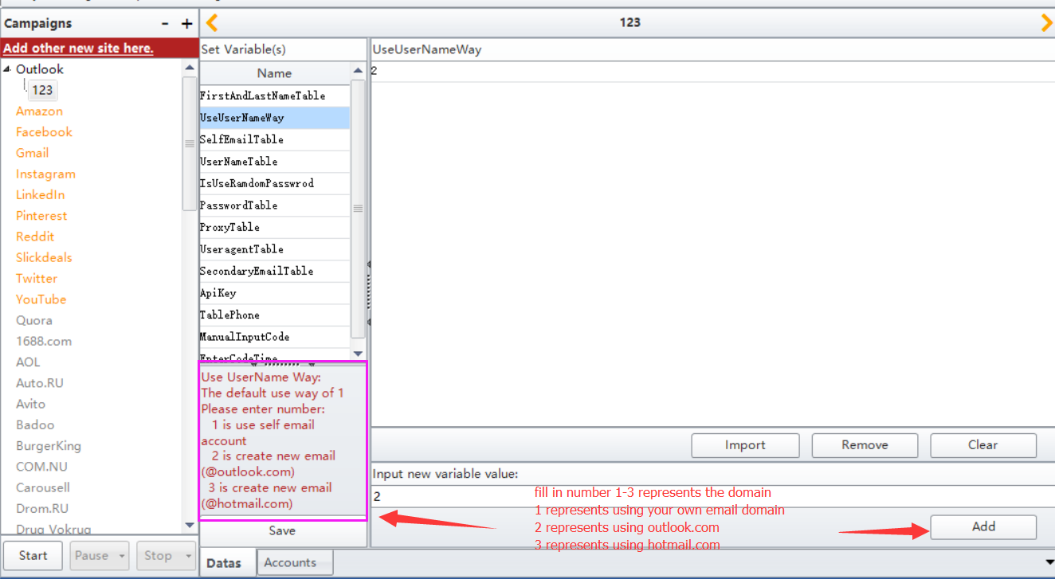

4. You can leave this one empty if you do not choose 1 in “UseUserNameWay”. If it is 1, then please fill in your email address
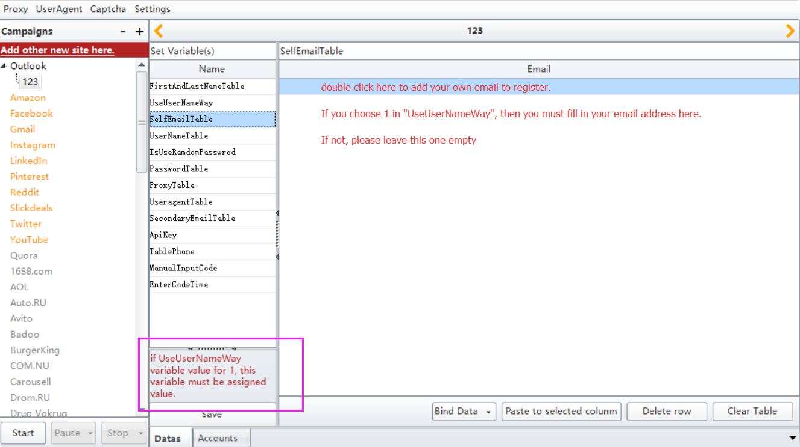

5. You can leave this one empty if you choose 1 in “UseUserNameWay”. If it is not 1, then please fill in the username
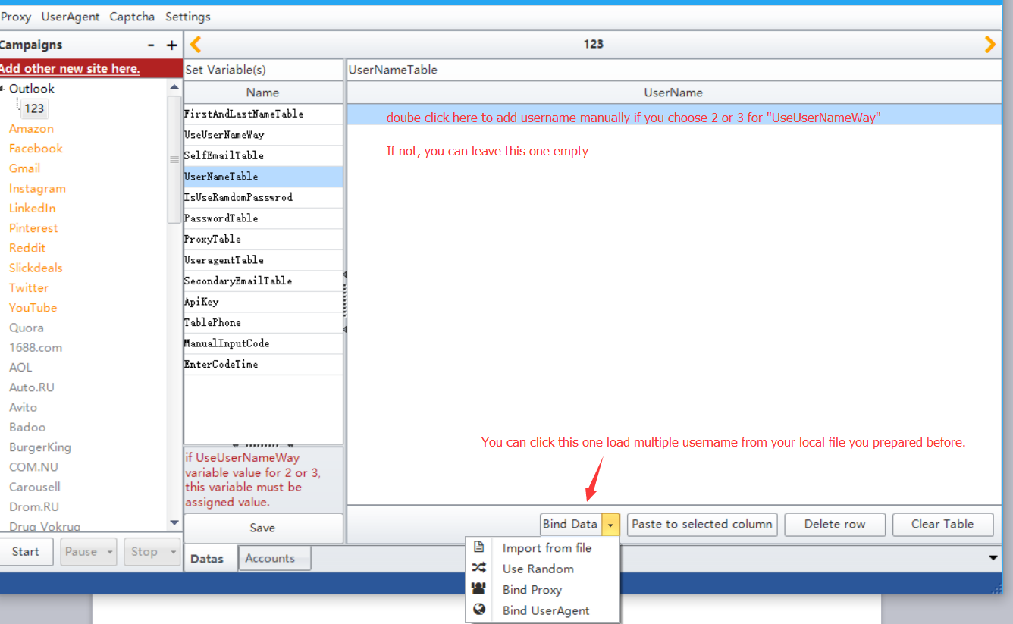

6. Enter number 0 or 1. 0 represents using the password you entered to register account. 1 represents program generate a password randomly when register accounts
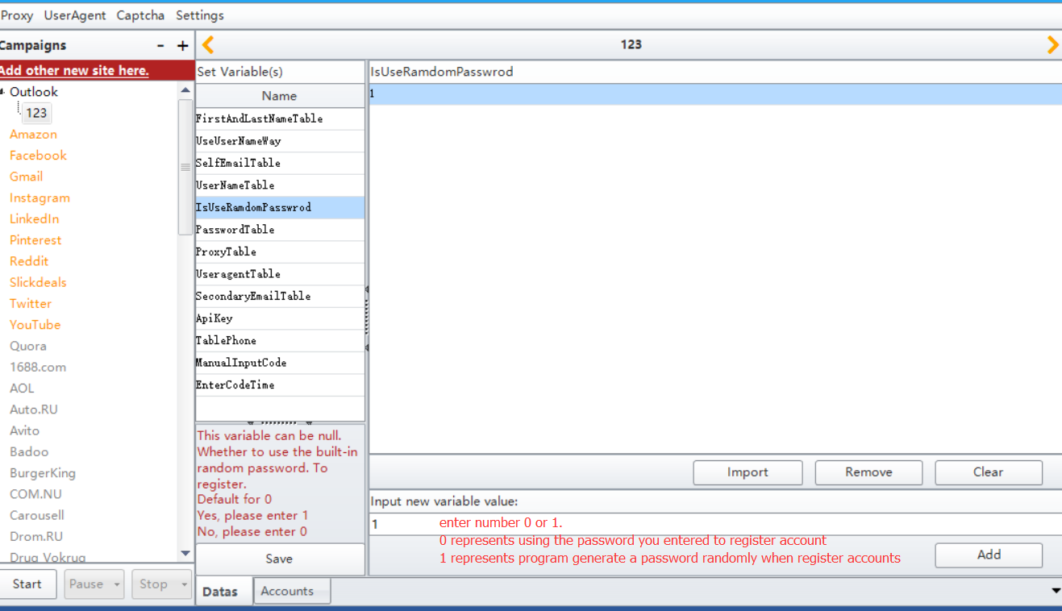

7. You can leave this one empty if you choose 1 in “IsUserRandomPassword”. If it is not 1, then please fill in your own password
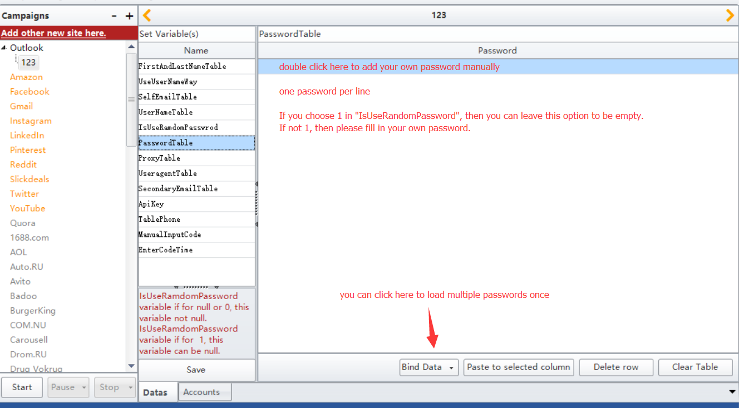

8. Add or load proxy. Or you can leave it empty. Same operation for Useragent
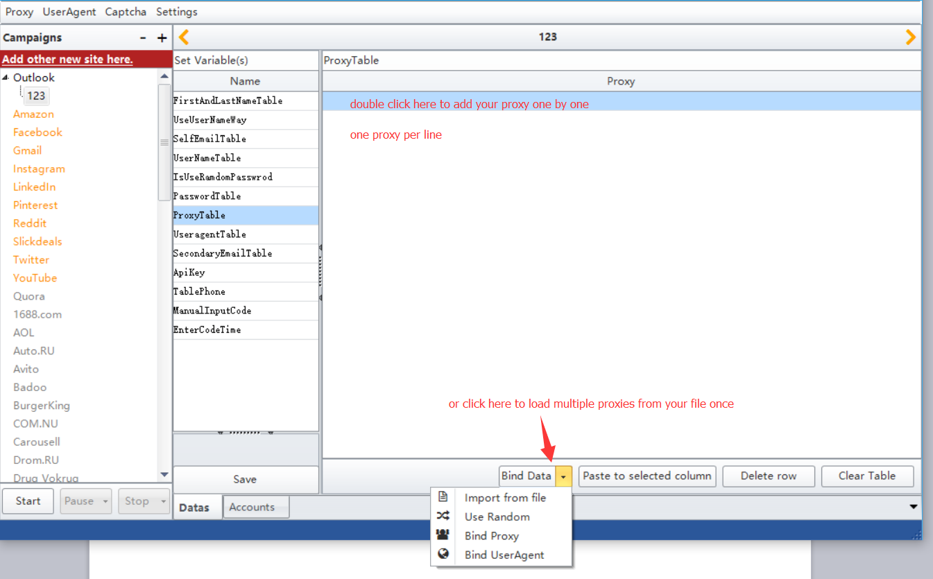

10. You can leave it empty. Or you can fill/load your email address as the recovery email when register
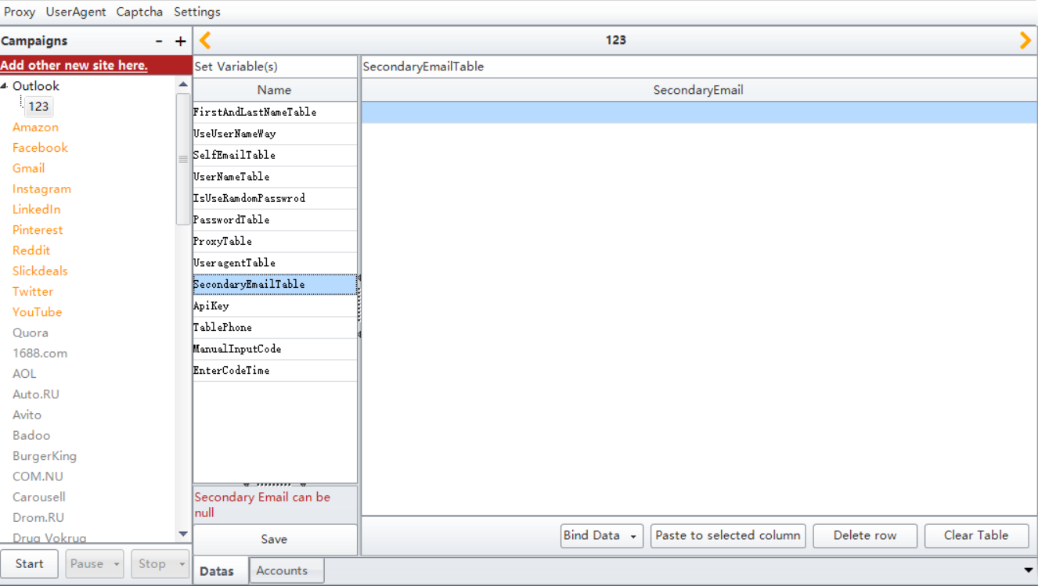

11. Use smspva service to add and verify the phone number
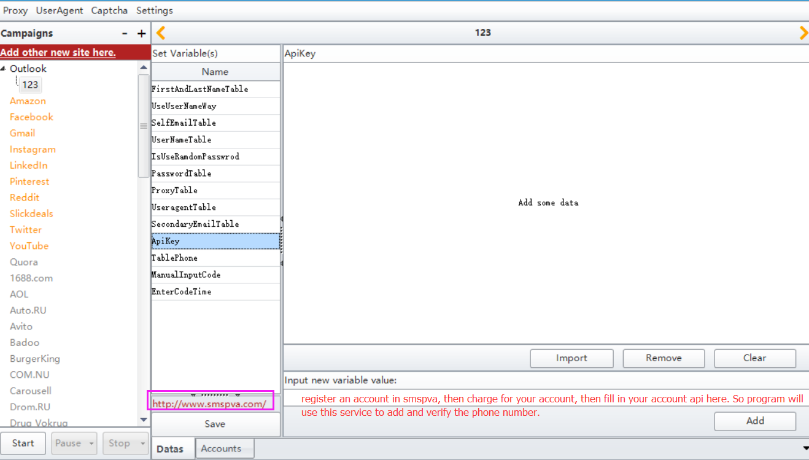

12. You can leave this empty if you fill in your api key in “ApiKey”. If not, please fill in your phone and your phone country code
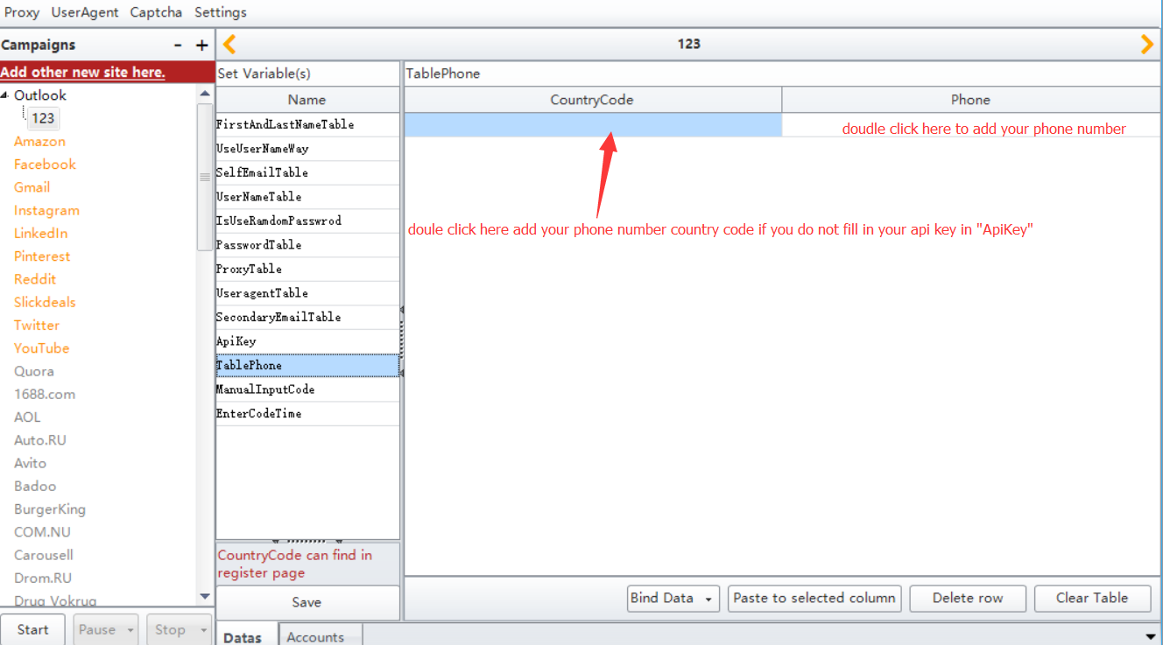

13. Enter 0 or 1. 1 represents you need to enter your phone code manually. 0 means program will use the smspva service you bought to enter code automatically
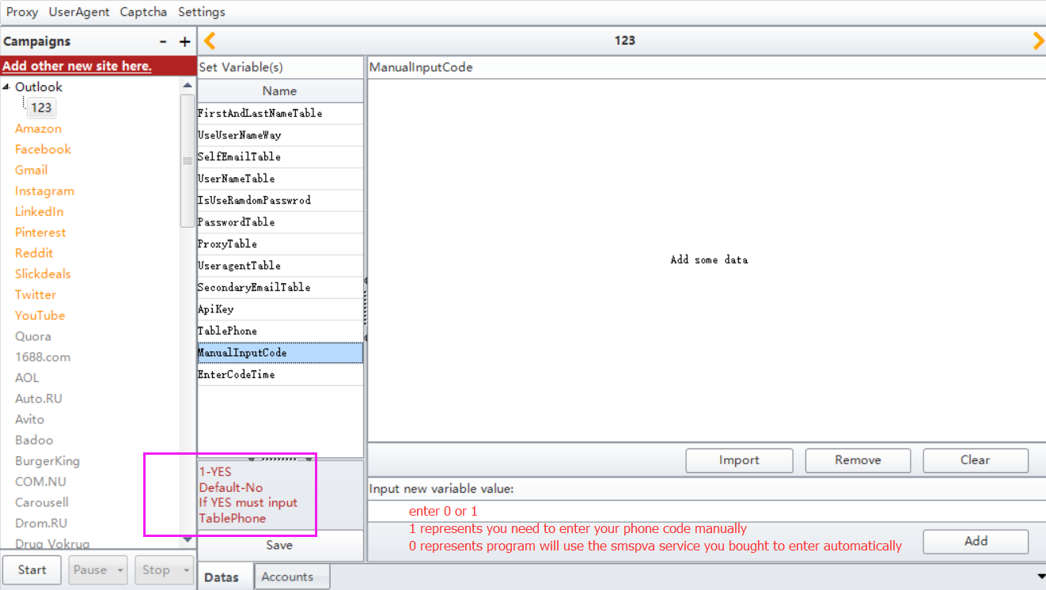

- You can leave this empty if you fill in your api key in “ApiKey”. If not, please fill in the time to let you fill in your phone code. The unit of it is milliseconds. 1000milliseconds=1s
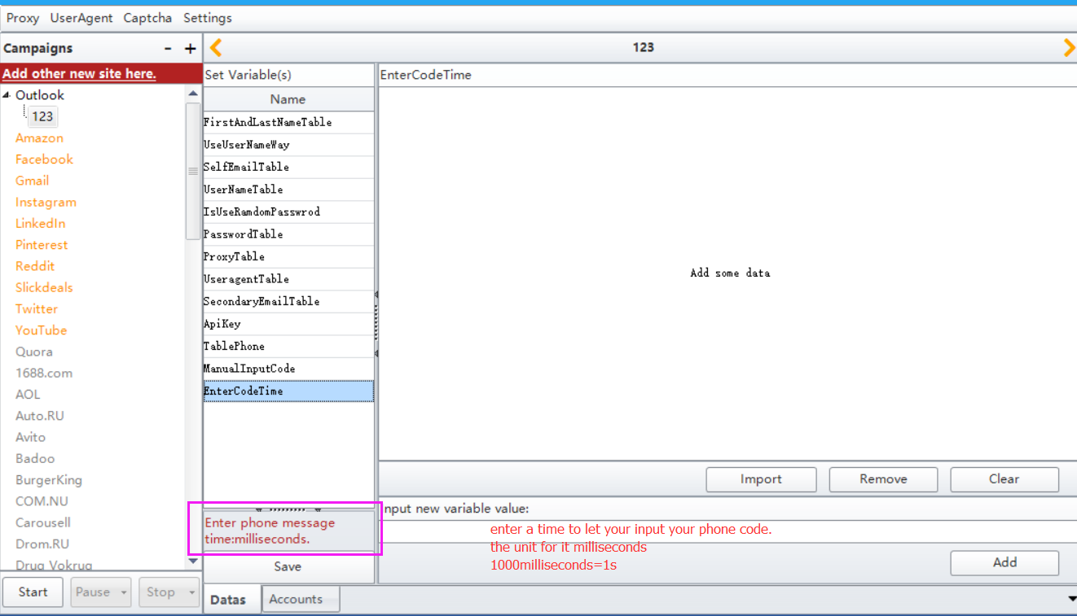

15. Click Save button to save the data you write
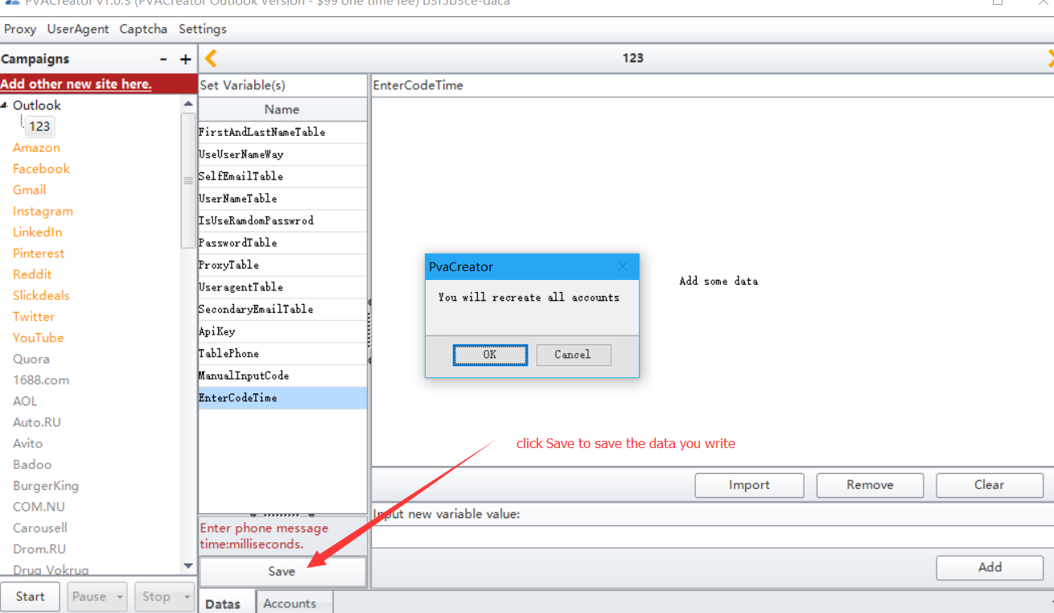

16. Select Accounts, then in this form, you can see all data you just write
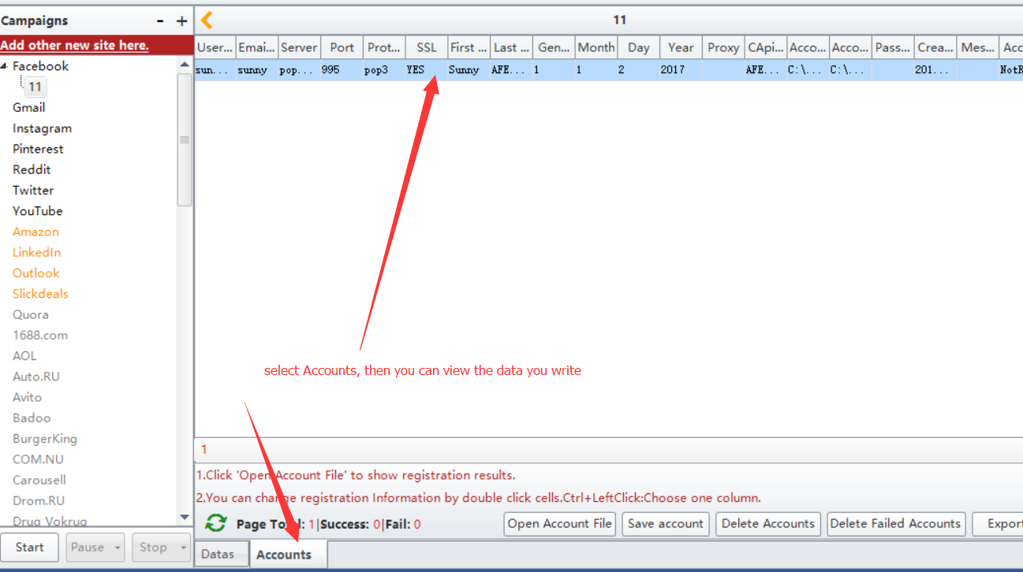

17. Click Start button to start to register accounts
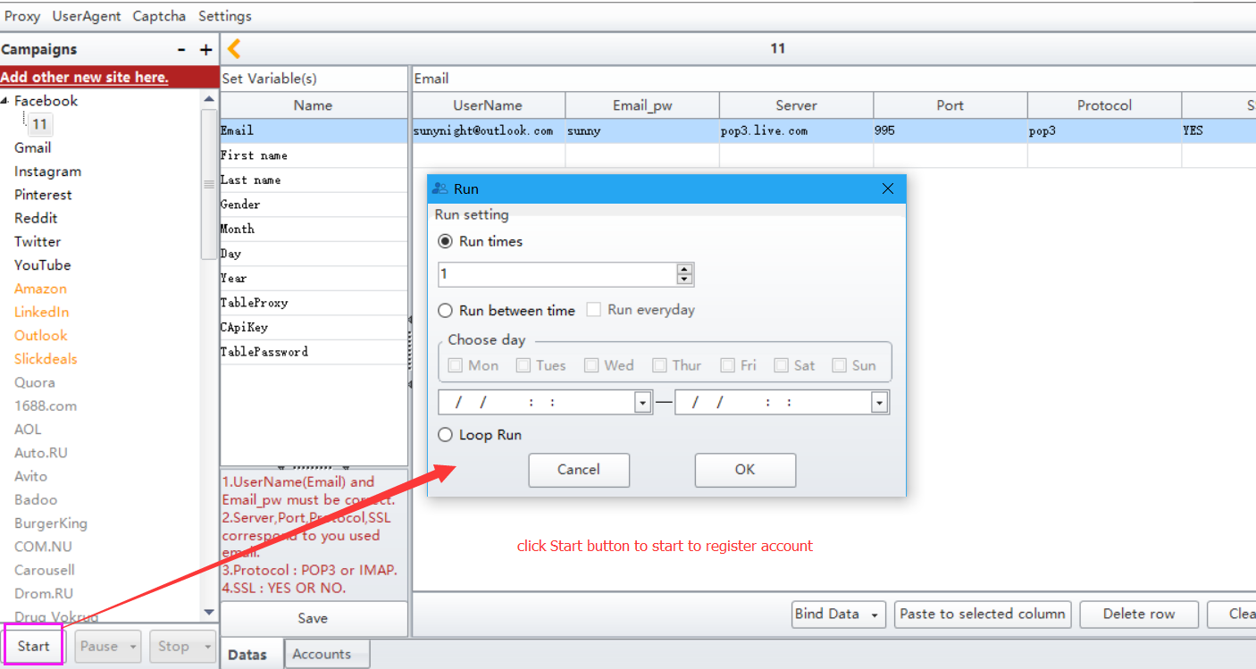

18. If this data has been created successfully, then the status here will be True. Else it will be false
